***ARTIFICIAL INTELLIGENCE ENABLED STUDENT MANAGEMENT SYSTEM***

**Project report in partial fulfillment of the requirement for the award of the degree of**

**Bachelor of Technology**

**In**

**<<CST/CSIT>>**

**Submitted By**

**NAMES AND RESPECTIVE ENROLLMENT NOs.**

SUPRATIM GHOSH  12021002023043

AISHEE GUHA BISWAS 12021002002038

MAHAK GUPTA 12021002022052

SUBHAJIT SAHA 12021002023048

GOURAV PATRA 12021002023049

ANUSHKA ADAK 12021002023033

**Under the guidance of**

**Prof. Dr. Srilekha Mukherjee**

**&**

**Prof. Sankhadeep Chatterjee**

**Department of CST/CSIT**



**UNIVERSITY OF ENGINEERING & MANAGEMENT, KOLKATA**

***CERTIFICATE***

This is to certify that the project titled **Artificial Intelligence Enabled Student Management System** submitted by **Supratim Ghosh (**University Roll No.:12021002023043**),Aishee Guha Biswas (**University Roll No.:12021002002038**)**,**Mahak Gupta (**University Roll No.:12021002022052**), Subhajit Saha(**University Roll No.:12021002023048**)**,**Gourav Patra (**University Roll No.:12021002023049**) and Anushka Adak (**University Roll No.:12021002023033**)**students of **UNIVERSITY OF ENGINEERING & MANAGEMENT, KOLKATA**, in partial fulfillment of requirement for the degree of Bachelor of Computer ScienceandTechnology/Information Technology, is a bonafide work carried out by them under the supervision and guidance of Prof. Dr. Srilekha Mukherjee & Prof.Sankhadeep Chatterjee during 3rd Semester of academic session of 2021 - 2025. The content of this report has not been submitted to any other university or institute. I am glad to inform that the work is entirely original and its performance is found to be quite satisfactory.

_______________________________ _________________________________

**Signature of GuideSignature of Guide**

_________________________________

**Signature of Head of the Department**

**ACKNOWLEDGEMENT**

We would like to take this opportunity to thank everyone whose cooperation and encouragement throughout the ongoing course of this project remains invaluable to us.

We are sincerely grateful to our guide Prof. Dr. Srilekha Mukherjee and Prof.Sankhadeep Chatterjee of the Department of CST/CSIT, UEM, Kolkata, for his wisdom, guidance and inspiration that helped us togo through with this project and take it to where it stands now.

Last but not the least, we would like to extend our warm regards to our families and peers who have kept supporting us and always had faith in our work.

SUPRATIM GHOSH

AISHEE GUHA BISWAS

MAHAK GUPTA

SUBHAJIT SAHA

GOURAV PATRA

ANUSHKA ADAK

**TABLE OF CONTENTS**

**ABSTRACT........................................................................ 5**

**CHAPTER – 1: INTRODUCTION............................................... 6**

**CHAPTER – 2: LITERATURE SURVEY 7**

**CHAPTER – 3: PROBLEM STATEMENT 8**

**CHAPTER – 4: PROPOSED SOLUTION 8**

**CHAPTER – 5: EXPERIMENTAL SETUP AND RESULT ANALYSIS 9**

**CHAPTER – 6: CONCLUSION & FUTURE SCOPE 14**

**CHAPTER – 7: BIBLIOGRAPHY 16**

**ABSTRACT**

The Artificial Intelligence enabled Student Management System is getting made in such a way that it will be able to scan the face of the user with the help of a facial recognition device and give him direct access to the website. Thus the students won’t have to go for options like filling forms for online attendance and it will also help teachers because it reduces the chances of manual attendance by teachers.

Added to this feature, the student will also be able to access many other features like making their CVs which can be done easily through the website. The university administration will also be able to use the emergency contact numbers of the students during times of need. For female students, the website will have connection to some emergency numbers and it will be connected to GPS (which can be turned on/off by the students depending on their choice). For some specially-abled persons, the website will have the contacts of the family doctors as well as the names of the medicines that can be used in times of emergency.

Since many students come from distant places, the website will contain the details regarding their attendance in specific classes using which the students can keep a track of their attendance and thus it won’t lead to poor performance during the exams. The website will also contain some of the important lectures uploaded in it which the student will be able to view later.

**INTRODUCTION**

Artificial Intelligence enabled Student Management system is a management information system for education establishments to manage student data. The student management system is an automated version of manual Student Management System.

The system can handle all the detail about a student.The details include: college details, students personal details, academic details etc.

It provides capabilities:

* for registering students in courses
* admitting students
* tracking student attendance
* submitting studentdocuments
* fee payment online

It is a web-based application.

Unlike traditional applications, it is accessible anytime, anywhere,with an Internet connection.

It needs lower requirements on the end user system and simplified architecture.

We ensure data integrity, privacy, and security in an open-access environment. Our project is based on the principle of accessing a website through facial detection.

**LITERATURE SURVEY**

The design and implementation of a comprehensive student information system and user interface is to replace the current paper records. College Staff are able to directly access all aspects of a student’s academic progress through a secure, online interface embedded in the college’s website. The system utilizes user authentication, displaying only information necessary for an individual’s duties. Additionally, each sub-system has authentication allowing authorized users to create or update information in that subsystem. All data is thoroughly reviewed and validated on the server before actual record alteration occurs. In addition to a staff user interface, the system plans for student user interface, allowing users to access information and submit requests online thus reducing processing time. All data is stored securely on SQL servers managed by the college administrator and ensures highest possible level of security. The system features a complex logging system to track all users access and ensure conformity to data access guidelines and is expected to increase the efficiency of the college’s record management thereby decreasing the work hours needed to access and deliver student records to users[1].

While the move towards the digital era is being accelerated every hour, biometrics technologies have begun to affect people’s daily life more and more. Biometrics technologies verify identity through characteristics such as fingerprints, faces, irises, retinal patterns, palm prints, voice, hand-written signatures, and so on. These techniques, which use physical data, are receiving attention as a personal authentication method that is more convenient than conventional methods such as a password or ID cards. The biometric personal authentication uses data taken from measurements. Such data is unique to the individual and remains so throughout one’s life[2].

The data framework is essential in gathering all information also data of all staff or part in one association to be in one spot. It is additionally given report on the other hand printed record to the client in the framework which will make the status of the student simpler to be checked. This new framework utilized database idea to store all the data which related with area application forms. This framework focused around database idea which is more solid. All learner information will be kept in a devoted database. By utilizing this database idea, a few issues, for example, information misfortune and harm could be stayed away from. This framework additionally focused to make a simple checking students' status. By utilizing this framework, staffs can check the students' status quicker in time contrasted with the current framework. Hence, the staff can lessen holding up time in place to check all the documents like some time recently. The other target is the issue that identified with looking and upgrading the information. Staffs can pursuit and upgrade the information methodically. This framework will give a few capacities, for example, looking and overhauling so as to help the staffs to control the information applications[3].

**PROBLEM STATEMENT**

* Most websites do not have a user friendly interface which makes it unaesthetic to the visitor.
* Many websites do not have an organized layout which creates a bad impression to the visitor.
* Most websites are not responsive in nature and lag updates making it repulsive in nature.
* Many websites are not secure making it uncomfortable for the users to share the relevant information in it.
* Most websites lag liveliness in them due to suspended animation.

**PROPOSED SOLUTION**

* The UI (user interface) of the website is highly interactive which makes it appealing. Since the website is made for students, it’s unique user interface makes it more approachable to the users.
* It has organized content with a clean layout and better design which can be accessed by the users comfortably.
* It has a responsive design framework and other better solutions for a smooth-flow website.
* The website is secure for the visitors.
* The website contains animation which makes it more attractive.

**EXPERIMENTAL SETUP AND ANALYSIS**

Our project is based on the principle of accessing a website through facial detection. In this report we have discussed about the website that the user can access after the his/her face is recognized by the Artificial Intelligence.

The website is a highly responsive website as it can be viewed on different types of screen sizes without causing any trouble to the user. The website has been made in such a way that it can adjust itself as per the screen size of the device on which it is being viewed.

The following are features of the website:

* The landing page, i.e., the page that pops up when the website is visited by the user, contains the picture of the university in the background. The logo of the university is preset at the top left corner. There is a navigation menu present on the upper-right side of the website which provide the user with different options like Log In, Contact, etc. There is also a sign up button that takes the user to the sign up page if he is not registered.

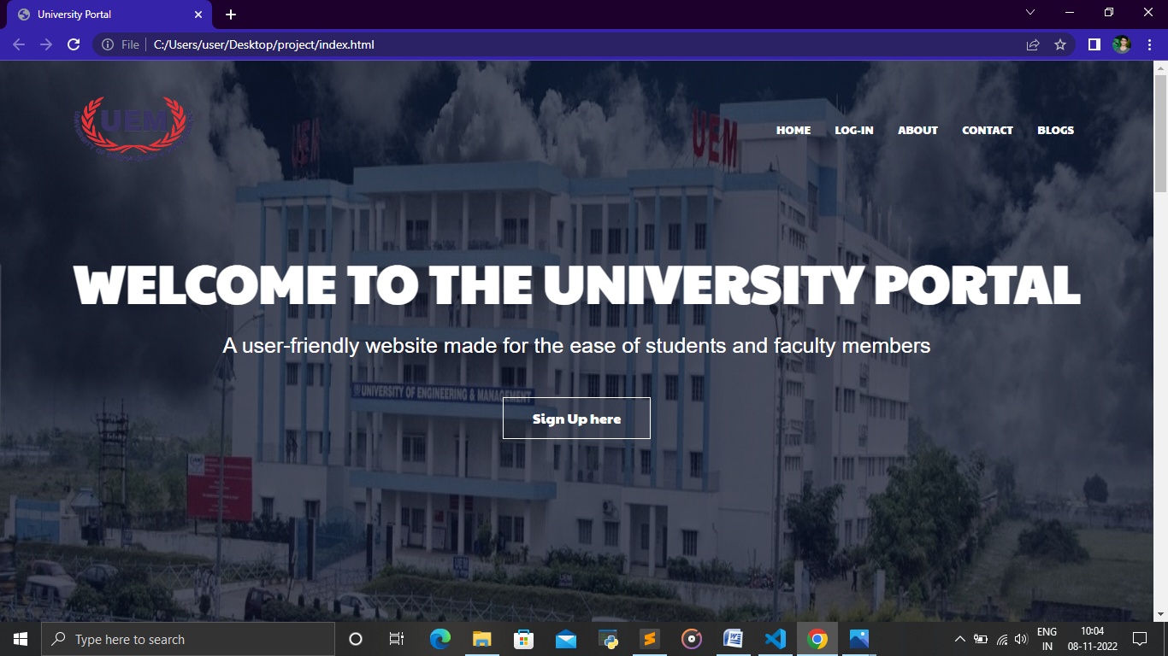

* On scrolling down, we get to see the features of the website. The website provides a large number of features to the students. Using the website the students will be able to view their attendance and get to know the important classes. There is also a Portfolio section on which the students will be able to upload their details and generate their CVs which provide highly helpful during the placement sessions. The Emergency section present here contains the contact numbers of the students’ family or friends that can be used during emergency.

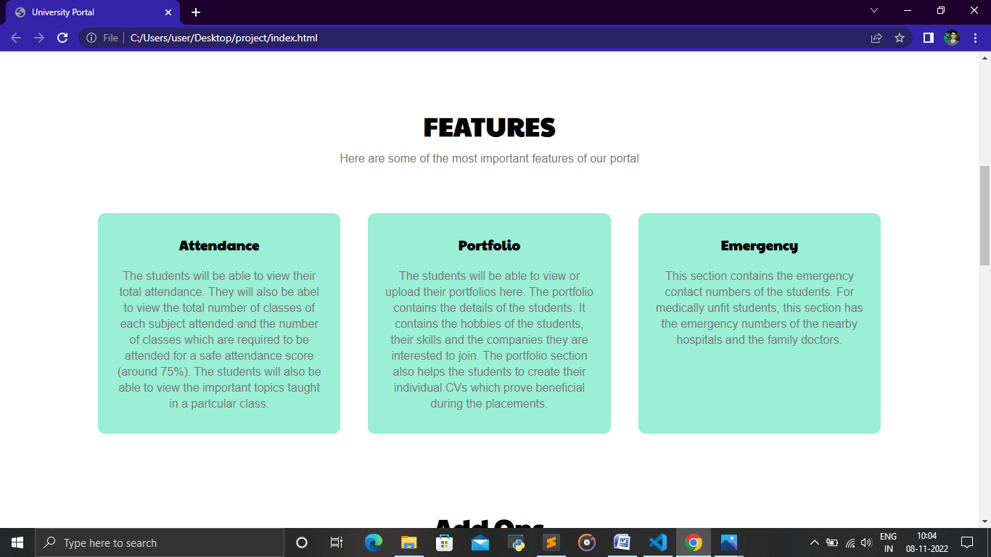

* On moving down, we get to see the colleges of the IEM-UEM group. On clicking on the desired college, the user will be directed to the website of that college.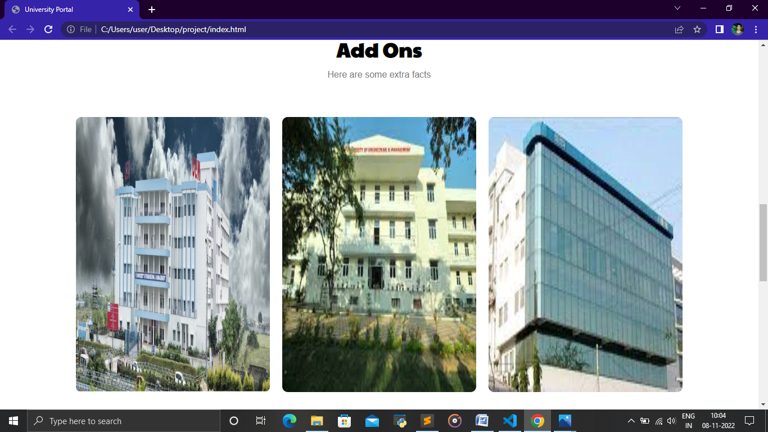
* Moving down, we are shown the Communities section. This section contains the different groups of our college like the Sports Club, the Quiz Club, the Rotaract Club, etc. The user gets a variety of options to choose from different clubs.

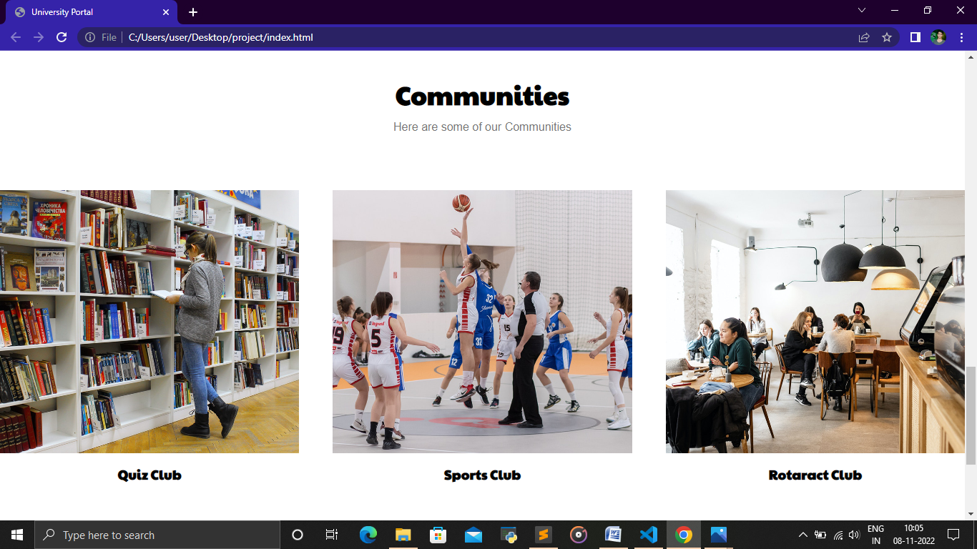

* At last, there is an About section that contains a small paragraph on our university.

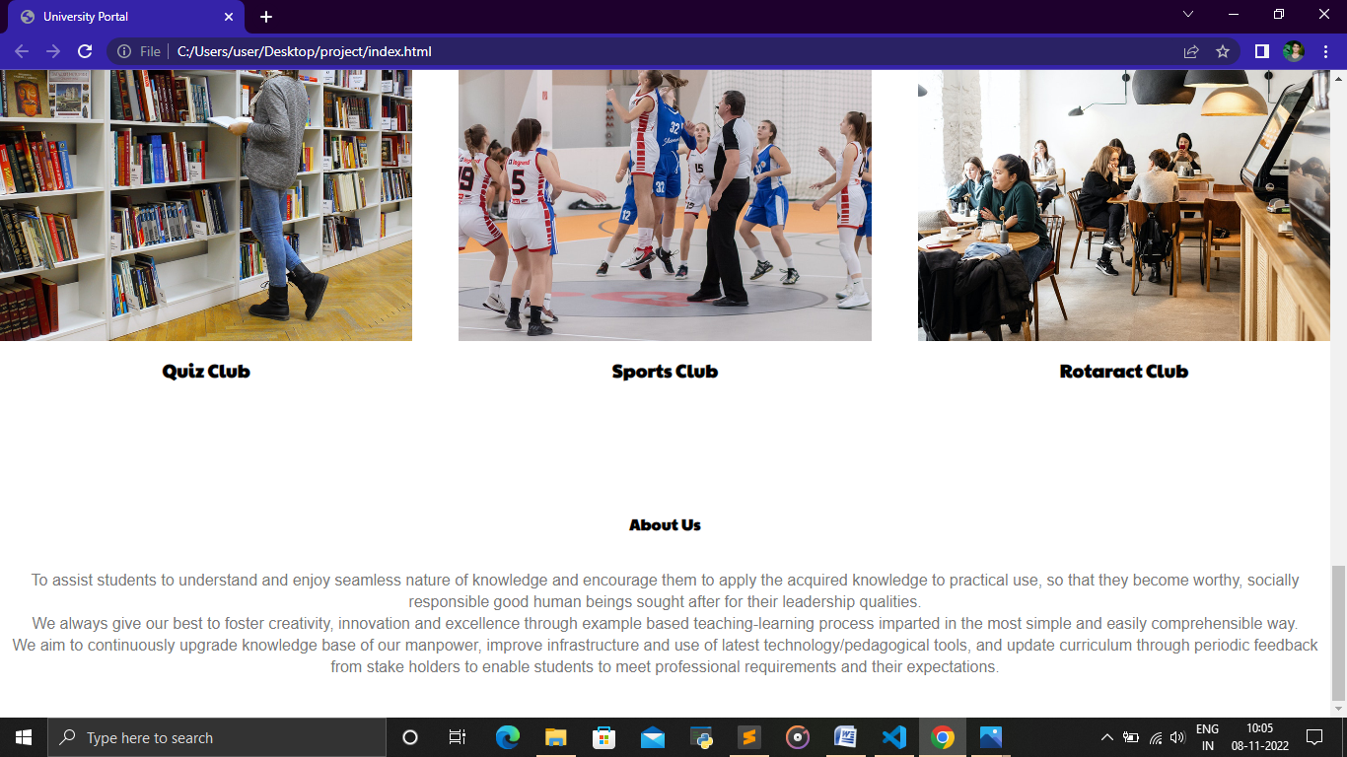

Now we move across the navigation menu that was present on the upper right side of the website and access them one by one. First comes the HOME page which denotes the landing page of the website. Then the other buttons like Log In, About, Contact, etc are present.

* On clicking the Log In button, the user is directed to the SIGN IN & SIGN UP FORM page. Here the user gets to choose between either of the two options. The sign in form has 3 fields for Username, Enrollment Number and Password. The user can also sign In using the social media handles.

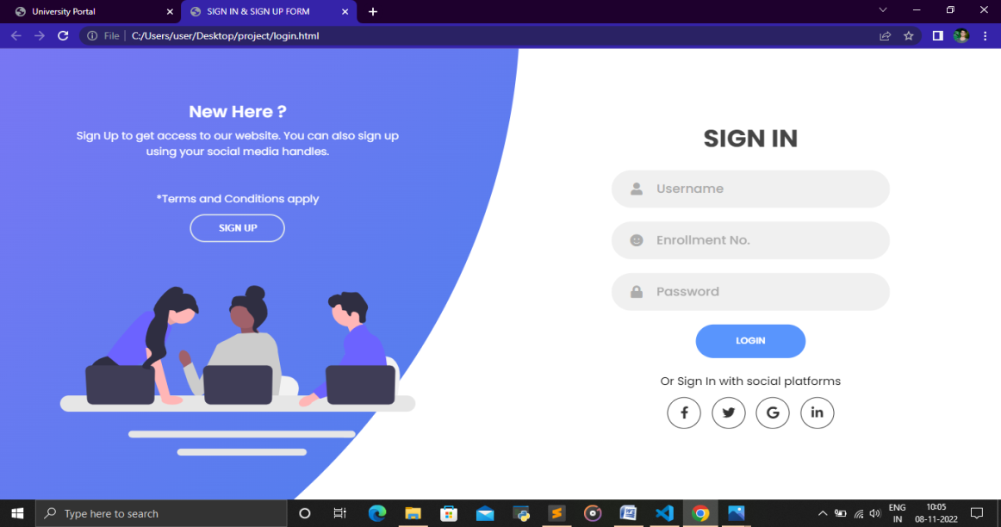

* If the user is new to the website or he has not registered then he can click on the Sign Up option which opens another form in which he can sign up. The sign up form has 3 fields that need to be filled up with the Username, E-Mail and password. The user can also sign up with social media handles here.

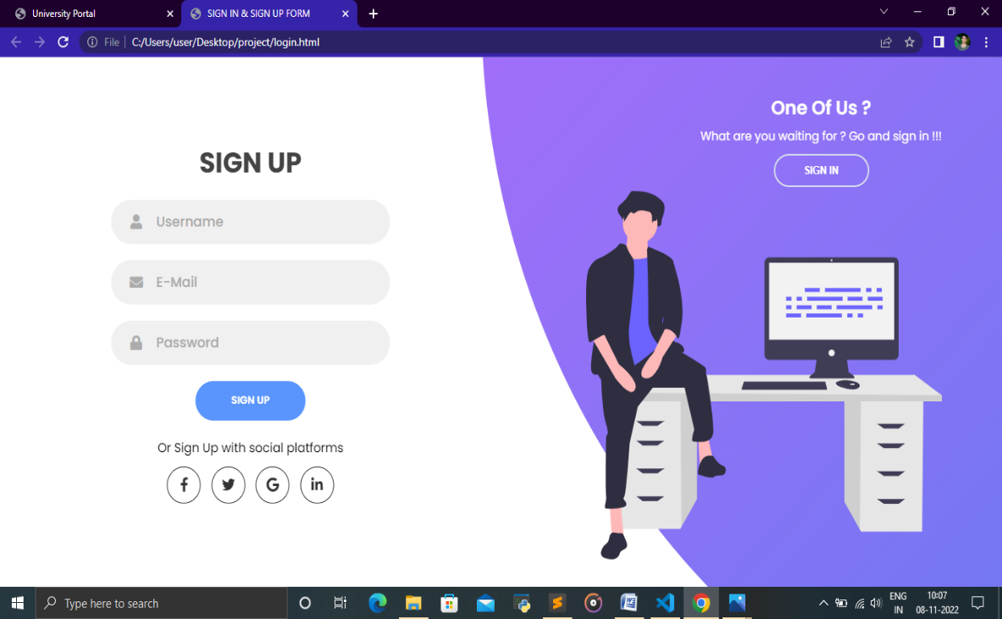

* Now, if the user selects the About button from the navigation menu then he is directed to the page which contains details about the university. The page is shown below.

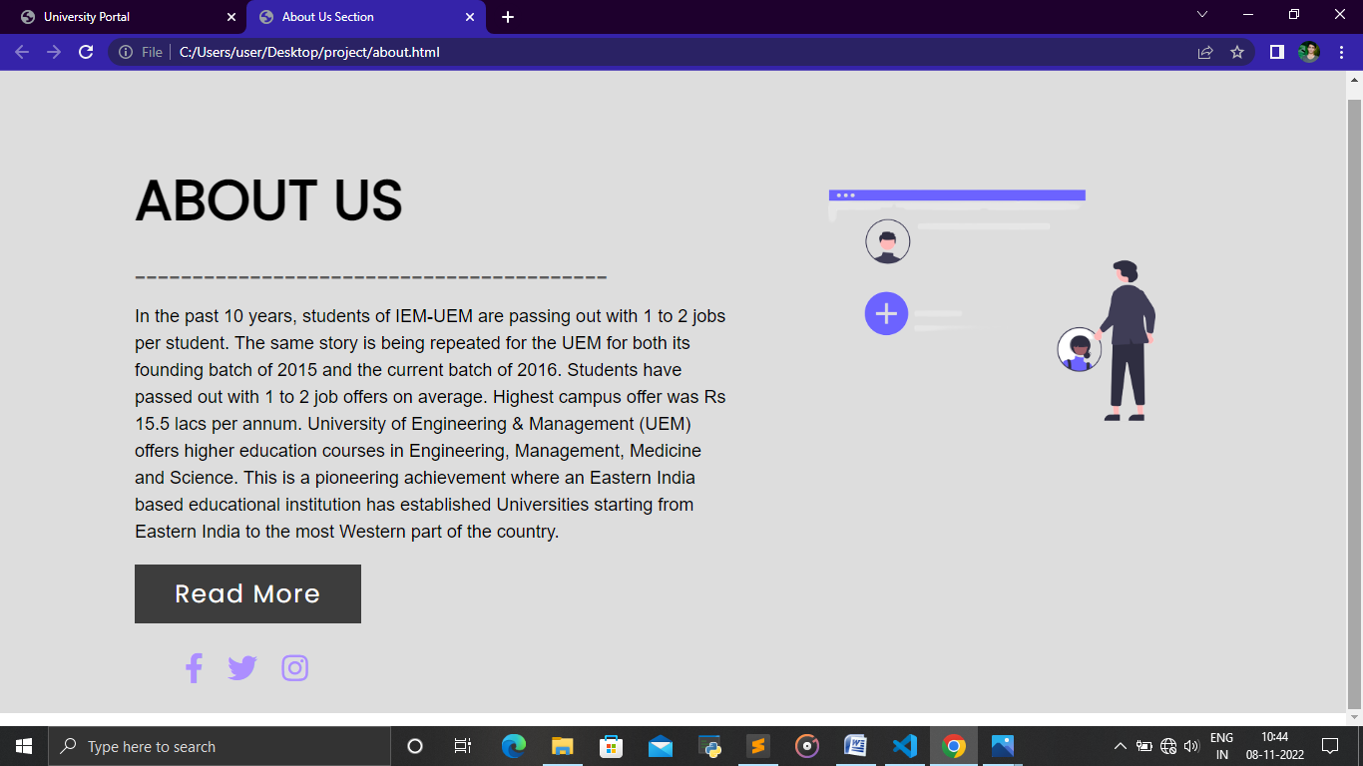

On clicking the Read More button the user is shown the University prospectus which can also be downloaded as a PDF.

Now, if the user selects the Contact button from the navigation menu then he is directed to another page that contains the ways of contacting the university. The page is shown below.

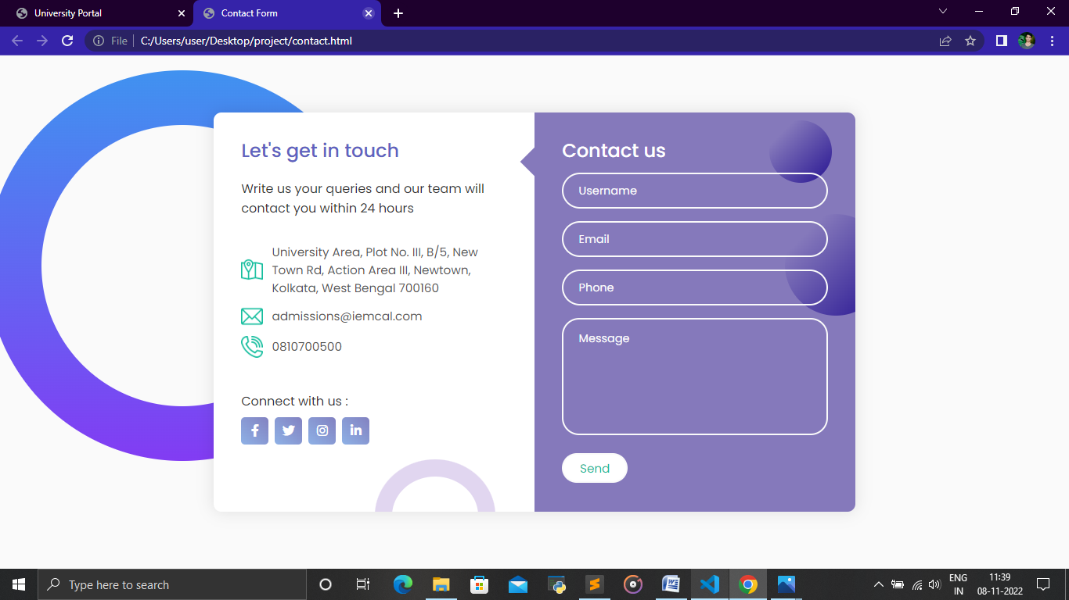

As we can see, this page has 4 input fields for Username, E-Mail, Phone and Message. This page also contains the address, email and contact number of the university. The user can also contact the university through social media also.

**CONCLUSION & FUTURE SCOPE**

The World is becoming a better place to live with new technological developments. AI Powered Chat-bots, Augmented & Virtual Reality, Data-analytics and Cloud Technology are revolutionizing the daily operations of various Industries. This is a good sign for the Educational Industry as well. Technology can pave the way for a better student success rate.

With some commendable work being done by iPaaS service providers and Student Information Systems (SIS), it’s easier now to fetch information from various platforms, analyze it and present it in a meaningful manner to teachers & parents. This can be a great aid to the teachers and parents as reports and suggestions will help them to:

**# Analyse student mistakes:**

The Student Information System (SIS) along with teacher’s input can compute the pain areas of students by analyzing the patterns in mistakes that they make in assignments and periodic tests. The next step to this can be the system giving suggestions to students to refer a specific book from the library or maybe an online study material which might help the student to cope up with the topic.

Similarly, teachers can be advised to spend more time with the students in the lab or studio for specific topics. Teachers will be able to unleash the actual power of the system by getting reports on Student-Topic Level Understanding.

**# Collect and Process Student Feedback:**

The SIS can be an effective tool for collecting feedback from the students. This feedback can be on various matrices such as – clarity of concepts; quality of study material shared, teaching techniques and examples shared by the teachers. On the basis of this feedback, anecdotal data can be gathered and analyzed to get meaningful reports.

**# Suggest Careers:**

This is a typical scenario of primary education at the end of which the students are not very sure of which career stream should be chosen. Now consider a student who has been part of an advanced SIS. The system would know a lot about each student’s capabilities, strengths, and weaknesses. Further to the availability of this data, the AI and Predictive Analysis Engine of the system can provide guidance to students about careers and streams to be chosen.

**# Assign Mentors to students:**

Mentor-Mentee mappings can be done using business rules. Such rules can be defined on the grounds of proficiencies of mentors and requirements of the mentees. Logical mappings will be achieved through automation hence saving a lot of time and efforts.

**# Monitor Student Health:**

For monitoring the holistic development of students, the data collected during periodic health check-ups can be collected and compared to an ideal growth rate of the student. This in itself has an infinite scope as a lot can be achieved through API integrations with Health Monitoring Systems. The output from such an ecosystem can also give suggestions on meals and its ingredients to ensure perfect health and growth rate of students.

**# Assist Recruitments:**

In the case of higher studies, the recruiting firms would want to short-list students on the basis of traits, positive incidents, academic excellence, growth, and achievements. The list of such students can be generated by applying various filters to the data available within the SIS. Such an approach will emerge as a great helping hand to Recruitment Cells of the institutes and for the recruiting firm as well.

The beauty of this [advanced Student Information System](https://www.academiaerp.com/student-information-system.php) will not just be its technical excellence but also the psychological support that it’ll provide to the students on the grounds of all the analytical data. Institutes can even plan a new department all together which will be using such reports and statistics to ensure student success mentally, physically and emotionally.

**BIBLIOGRAPHY**

1. SR Bharamagoudar, RB Geeta, and SG Totad. Web based student infor-  
   mation management system. International Journal of Advanced Research in  
   Computer and Communication Engineering, 2(6):2342–2348, 2013.
2. Unnati A Patel and S Priya. Development of a student attendance man-  
   agement system using rfid and face recognition: a review. International  
   Journal of Advance Research in Computer Science and Management Stud-  
   ies, 2(8):109–119, 2014.
3. Er Saurabh Walia and Er Satinderjit Kaur Gill. A framework for web based  
   student record management system using php. International Journal of  
   Computer Science and Mobile Computing, 3(8):24–33, 2014.